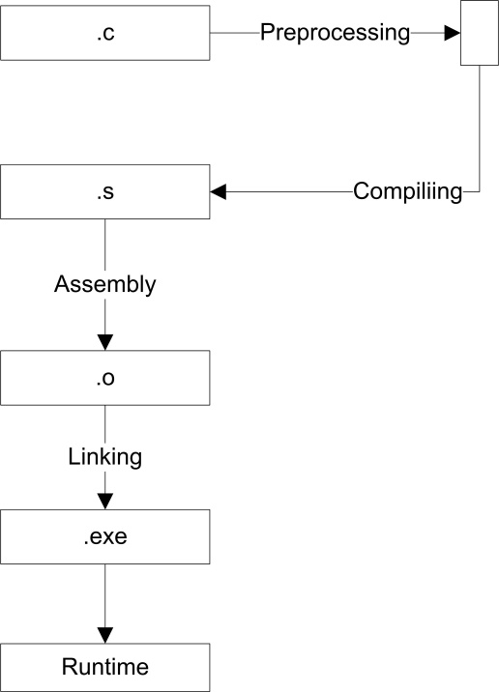

Preprocessing:   
- Read Library directives  
- Remove Comments

Directives are LINES that in C/C++ program that begins with a ‘#’ symbol.

#include <stdio.h>  
(command) (arguments)

* <stdio.h> is to be found in the library-include in the user directories
* “stdio.h” is to be found in the user-defined directories, defaulted path is the same directory as the C/C++ file

Preprocessing Command Lines:  
g++ -E a.cpp  
Output: Printout of lines of loaded directive.  
Assembly command Line:   
g++ -S a.cpp  
Output: .s file  
Object file command Line:   
g++ -c a.cpp  
Output: .o file  
Full compilation command Line:   
g++ a.cpp  
Output: .exe file

Reading Link: <https://www.calleerlandsson.com/the-four-stages-of-compiling-a-c-program/>

* “String Literally” is whatever in between the “ “ with an escaped character /0
* A statement is a line end with ;

Identifies

* Name
* Variables and Functions have names
* Cannot starts with digits, e.g. 2_abcd, 2abcd, 234abcd
* A-Z, a-z, digits 0-9, _ (Underscore)

**Compile (.s file)**

* Translation of C Code into Assembly code

**Assembling (.o file)**

* Translation of Assemble code into incomplete machine code
* Linking error usually means a called component is missing

